The Village

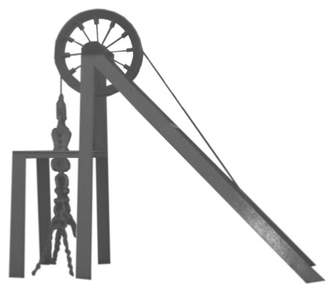

Surgery

Mask wearing in our surgery is now a personal preference.

This applies to both patients and staff.

Some staff may still wear a mask, especially when conducting procedures in close proximity.

We would still encourage patients who are immune suppressed or have respiratory symptoms to continue to wear masks in surgery.

This may be subject to change in the future.

Thank you.

The Village Surgery

